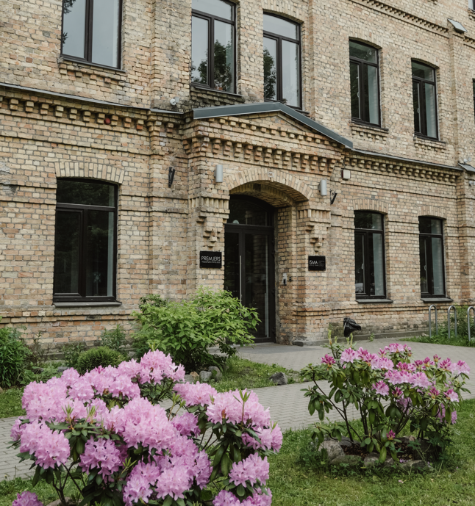
68th ESReDA Seminar

Multidisciplinary Approaches to Resilience Assessment in Critical Infrastructures and Digital Systems

May 14th - 15th, 2026

Riga Nordic University, Riga, Latvia

Announcement and 1st CALL FOR PAPERS

Scope
The evolving complexity and interdependence of critical infrastructures- alongside their growing reliance on digital technologies- pose unprecedented challenges for resilience assessment and management. As infrastructures become increasingly interconnected, the potential for cascading failures, systemic disruptions, and hybrid threats (both physical and cyber) demands a comprehensive, multidisciplinary approach. The 68th ESReDA Seminar on “Multidisciplinary Approaches to Resilience Assessment in Critical Infrastructures and Digital Systems” aims to provide a platform for the exchange of scientific knowledge, practical insights, and methodological advancements related to the resilience of complex socio-technical systems. This seminar will explore the integration of engineering principles, information and communication technologies (ICT), risk and systems sciences, human and organisational factors, and public policy to advance a holistic understanding of resilience. Building upon the outcomes of previous ESReDA seminars, this event is part of the ESReDA project group work on “Resilience Assessment of Critical Infrastructure” and will foster collaborative dialogue among academic researchers, industry practitioners, regulators, and other stakeholders. The seminar seeks to promote the development of rigorous, evidence-based frameworks and tools for resilience assessment and enhancement, in the context of increasing uncertainty, technological transformation, and societal expectations
The seminar will serve as a platform to reflect on and advance understanding of the following key topics:
- Multidisciplinary models and frameworks for resilience assessment of critical infrastructures
- Integration of physical and digital resilience strategies, including cross-domain risk modelling and interdependency analysis
- Systemic risk analysis in complex and interconnected socio-technical environments
- Security and resilience of cyber-physical systems: methods for detection, response, and recovery
- Metrics and indicators for resilience assessment: development, validation, and practical application
- Advanced simulation techniques and digital twin technologies for stress-testing and scenario planning
- Artificial intelligence and machine learning in predictive resilience and real-time decision support
- Data-driven and sensor-based approaches for early warning, situational awareness, and adaptive infrastructure management
- Human and organisational resilience, emphasising communication, coordination, and non-technical capabilities
- Resilience engineering in urban systems, with a focus on smart cities, critical services, and infrastructure interdependence
- Governance, regulation, and policy frameworks for enhancing resilience in critical infrastructures
- Case studies and empirical insights drawn from past disruptions across sectors
- Participatory methods and stakeholder engagement in resilience planning and evaluation processes
- Resilience in the context of climate change and energy transition, including strategies for adaptation and transformation
- Modelling interdependent and cascading sequences of event, with a focus on NaTech type scenarios involving jointly natural hazards and technological accidents
- Educational programs and capacity-building initiatives to support cross-sectoral resilience competencies

The 68th ESReDA Seminar will serve as a forum for critical reflection and interdisciplinary dialogue on the challenges, methodologies, and innovations in the assessment and enhancement of resilience in critical infrastructures and digital systems. The seminar aims to foster a deeper understanding of how multidisciplinary approaches - spanning engineering, data science, cyber-physical systems, human factors, and policy - can be integrated to improve the robustness, adaptability, and recoverability of complex socio-technical systems.
Target groups and domains of application
The seminar invites contributions from a broad range of stakeholders engaged in the design, operation, regulation, and study of critical infrastructures and digital systems. This includes academic researchers, industry professionals, regulators, system developers, infrastructure operators, consultants, and representatives of public authorities.

Submissions should address multidisciplinary perspectives on the assessment, modelling, enhancement, and governance of resilience in complex, interdependent systems. Contributions may focus on sector-specific or cross-sectoral approaches, and are particularly encouraged from the following domains:
- Energy infrastructure: including nuclear and non-nuclear power generation (fossil, renewable), smart grids, energy storage, and distribution networks.
- Process and high-risk industries, such as oil and gas, chemical and petrochemical sectors, where operational continuity and digital control systems intersect.
- Advanced manufacturing systems: particularly those adopting Industry 4.0 technologies, industrial IoT, and cyber-physical systems.
- Hydrogen and emerging energy technologies: focusing on infrastructure safety, integration, and resilience under uncertainty.
- Digital infrastructures: including cloud computing, data centres, telecommunications networks, and critical software platforms.
- Transport systems: rail, road, air, and maritime infrastructure, including autonomous mobility, intelligent transport systems, and logistics resilience.
- Aerospace and aviation: digital resilience in complex supply chains and critical safety systems.
- Urban systems and smart cities: integrated urban infrastructure (mobility, utilities, ICT) and their exposure to physical and cyber threats.
- Critical service delivery: water and wastewater systems, public health infrastructure, and emergency services.
- Public sector and governance institutions: addressing resilience policy, regulatory frameworks, and inter-organisational coordination.

This seminar aims to address resilience to a wide range of hazards and disruptions, including natural disasters, technological accidents, hybrid and Na-Tech events, cybersecurity incidents, and systemic interdependencies.

ESReDA Project Group on Resilience Assessment of Critical Infrastructure
The project group (PG) has started in 2022 and focuses on resilience applications in critical infrastructures, promoting cross-disciplinary collaboration and application of proven methods from one infrastructure domain (e.g. energy, transportation, etc.) to other infrastructures, including also the issue of NaTech scenarios linking natural hazards and technological accidents. The PG partners focus on the specific infrastructure domain they are working on and promote methodological exchange of successful methods or approaches. The aim of the PG is to develop and propose an integrated approach for quantitative resilience assessment, including management decisions (comparison of solutions for investment, maintenance) in a context of uncertain scenarios (global change and emerging threats, NaTech scenarios). The PG continues the work done in the previous ESReDA project group “Resilience Engineering and Modelling of Networked Infrastructure”, led by the University of Nottingham (Dr Rasa Remenyte-Prescott, Prof. John Andrews, Kate Sanderson) during 2018-2021. The PG work was accomplished by publishing a book, “Modelling the Resilience of Infrastructure Networks” (Eds. Rasa Remenyte-Prescott, Vytis Kopustinskas) in late 2021.

Organisation
ESReDA and Riga Nordic University in Riga, Latvia, jointly organise the Seminar.
Location: Riga Nordic University (RNU), 1 Valērijas Seiles Street, Building 5, Riga, LV-1019, Latvia

Local Organising Committee (LOC)
- Laila Zemīte (Riga Nordic University, LATVIA)
- Antonina Djakona (Riga Nordic University, LATVIA)
- Andrejs Cinis (Riga Nordic University, LATVIA)
- Anete Plota (Riga Nordic University, LATVIA)

Relevant dates, abstracts and papers submission, preliminary schedule:
- Submission of abstracts: before 20 December 2025.
- Notification to authors: 20 January 2026
- Submission of camera-ready papers: 31st March 2026

- 13 May 2026: ESReDA joint activities, including the Board of Directors meeting and project group sessions.
- 14–15 May 2026: The 68th ESReDA Seminar will take place on 14 May (full day) and continue on 15 May (until lunchtime).
- A Tour from RNU will be organised on the afternoon of 15 May for interested participants.

Technical Program Committee
- John Andrews University of Nottingham, United Kingdom
- Anne Barros CentraleSupélec, France
- Julien Baroth University of Grenoble, France
- Christophe Bérenguer University of Grenoble, France
- Jelena Caiko Riga Nordic University, Latvia
- Marko Čepin University of Ljubljana, Slovenia
- Micaela Demichela Politecnico di Torino, Italy
- Antonina Djakona Riga Nordic University, Latvia
- Deniss Djakons Riga Nordic University, Latvia
- Mohamed Eid RiskLyse, France
- Gianluca Fulli EC Joint Research Centre, Italy
- Saulius Gudžius Kaunas University of Technology, Lithuania
- Antonio Guillen Ingeman, Spain
- Vytis Kopustinskas EC Joint Research Centre, Italy
- Pierre-Etienne Labeau Université Libre de Bruxelles, Belgium
- Tomasz Nowakowski Wroclaw University of Science and Technology, Poland
- Rasa Remenytė-Prescott University of Nottingham, United Kingdom
- Sigitas Rimkevičius Lithuanian Energy Institute, Lithuania
- Giovanni Sansavini ETH Zürich, Switzerland
- Jean-Marc Tacnet University of Grenoble, France
- Agnieszka Tubis Wroclaw University of Science and Technology, Poland
- Bogdan Vamanu ‘Horia Hulubei’ National Institute of Physics and Nuclear
Engineering, Romania
- Madina Mansurova Al-Farabi Kazakh National University, Kazakhstan
- Nadežda Kuņicina Riga Technical University, Latvia
- Anna Mutule Riga Technical University, Latvia
- Artjoms Obusevs ZHAW School of Engineering, Switzerland
- Karol Kowal National Centre for Nuclear Research, Poland
- Laila Zemīte Riga Nordic University, Latvia

Procedure to submit an abstract, paper and to register.
The abstracts, not exceeding 400 words, should address:
- Objectives of the paper
- Relevance to the Seminar
- Novelty or relevant contribution to the subject
- Methods and findings
- Main conclusions

The language of the seminar is English.
Final papers (4 to 12 A4 pages) should be submitted after the notification to the authors. Extended abstracts (2-5 pages A4 pages including references) are an alternative to full papers. ESReDA will publish both extended abstracts and full papers in the online proceedings.
Authors wishing to present a paper are invited to submit an abstract online at https://easychair.org/my/conference?conf=68thesredaseminar and send their submission in copy to isma@isma.lv and/or Laila.zemite@isma.lv
Guidance for authors and speakers about the format to be used for ESReDA camera-ready papers will be sent directly to authors who expressed interest in writing a contribution.
More information will be announced soon on the ESREDA webpage: http://www.esreda.org/

Seminars Proceedings
The final proceedings of the 68th Seminar will be edited in the form of a Technical Report and e-published with public access.
Registration and Seminar Fee
Registration will be accepted until 15th April 2025. A registration form and information package for the venue will be made available on the ESReDA website (http://www.esreda.org/).

The registration fees are €300. Fees are to be paid by bank transfer only to the ESReDA account:
Holder: ESReDA
Bank: BNP Paribas Fortis Bank, Boulevard Jamar 1 D, 1060 Bruxelles, Belgium
IBAN: BE69 0012 3728 1678
BIC: GEBABEBB
Subject: 68th ESReDA Seminar – Registration fees

Fee waiver:
- Fees will be waived for one speaker per accepted paper.
- The participation fee for ESReDA members is taken care of by the Seminar (up to 3 participants per ESReDA member).

For follow-up and more details, you may contact Prof. (Laila.Zemite@isma.lv) with Antonio Guillén (ajguillen@us.es) in Cc

Location: Riga, Latvia
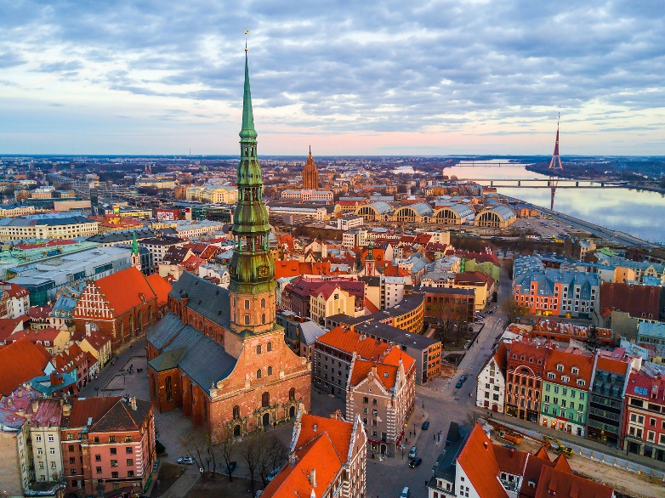
The 68th ESReDA Seminar will take place in Riga, the capital of Latvia and a key cultural, scientific, and economic hub of the Baltic region. Founded in 1201, Riga is a UNESCO World Heritage Site known for its well-preserved medieval Old Town and one of the world’s richest collections of Art Nouveau architecture. Today, Riga combines historical charm with a dynamic and modern atmosphere. As Latvia’s largest city, it hosts major academic institutions, thriving technology and innovation sectors, and an active international community. Riga is easily accessible, with direct flight connections to major European cities and a compact, walkable city centre. Participants will have the opportunity not only to engage in scientific dialogue but also to explore the city's unique heritage and vibrant cultural life. A guided excursion will be offered on the afternoon of 15 May 2026 for those wishing to discover Riga and its surroundings further.
Riga Nordic University (RNU)
At Riga Nordic University (RNU), we are committed to shaping the future of education by combining academic excellence with innovation. As a modern university, we offer a dynamic learning environment where students are exposed to cutting-edge research, industry-focused programmes, and a diverse global community. Established in 1994, RNU is a dynamically growing university headquartered in Riga, Latvia, with additional branches in Daugavpils, Latvia, and Fergana, Uzbekistan. RNU is a modern higher education institution that offers a continuous and competitive range of educational programmes, from pre-school to secondary school, including the International Baccalaureate programme at Secondary School "Premjers", as well as doctoral study programmes. To ensure that graduates acquire the best knowledge and practical skills for careers in high-demand fields, RNU continuously modernises its study solutions. As a result, RNU graduates are highly sought after by employers, with many securing leading positions in public and private sector institutions, as well as becoming successful entrepreneurs.

Getting to Latvia – Arriving in Riga
Latvia is in Northern Europe, on the eastern shore of the Baltic Sea, and is a member of the European Union and the Schengen Area.
The easiest way to reach Latvia is via its capital, Riga, which is home to the largest and busiest airport in the Baltics:
- Riga International Airport (RIX) is located approximately 10 km from the city centre.
- The airport offers direct flights to and from more than 80 destinations in Europe, Scandinavia, and beyond, operated by major airlines such as AirBaltic, Lufthansa, Ryanair, Finnair, K.
- Taxis, app-based ride services (e.g. Bolt), and public buses (No. 22) provide convenient connections from the airport to the city centre in 20–40 minutes.
- Riga offers a wide selection of hotels and apartments, particularly concentrated in the central part of the city near the historic Old Town

Getting to Riga Nordic University (RNU)
ISMA University is centrally located in Riga and easily accessible by public transport or taxi:
- Address: 1 Valērijas Seiles Street, Building 5
- From Riga International Airport: By taxi or ride-hailing: 30–50 minutes; By public transport: Bus No. 22 to the city centre, then transfer to trolleybus or tram (total ~35–60 minutes)
- From Riga Central Railway or Bus Station: Walking: approx. 50 minutes, By public transport: several tram and trolleybus lines pass nearby (e.g., tram No. 7 or trolleybus No. 15)
Riga’s public transport system is operated by Rīgas Satiksme (www.rigassatiksme.lv), covering trams, trolleybuses, and buses. Tickets can be obtained through multiple convenient methods:
- Retail outlets such as Narvesen kiosks, Rimi supermarkets, Rīgas Satiksme customer service centres, and post offices—more than 400 locations across Riga offer ticket sales
- Smartphone apps like Mobilly or Rīgas Satiksme Code Ticket, where you can buy and activate tickets digitally
- Only Bus route No. 22 (airport connection) single ride tickets can be purchased directly from the driver, but payment must be by bank card in this case
- Every time you board a tram, trolleybus, or bus, tap your e‑talons card or scan your smartphone ticket on the validator at the vehicle entrance. A green light confirms valid registration
- For short stays (e.g. to get between the airport, hotels, and conference venue), a 24-hour or 90-minute time ticket offers flexibility and ease.
- Those staying several days or expecting to ride multiple times daily should consider a 3‑day or 5‑day pass, or a monthly ticket if eligible.

