62nd ESReDA Seminar On

Managing the unexpected:

designing systems to embrace disorder

for increasing asset reliability

April 12th – 13rd, 2023, University of Twente, the Netherlands

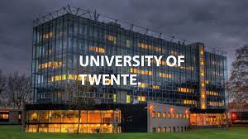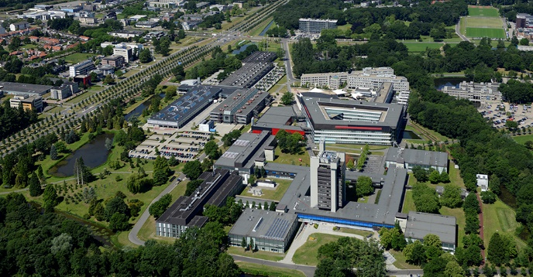

Announcement and Call for Papers

Scope of the seminar
Dealing with complex systems have certain characteristics that require consideration to be managed successfully. Understanding and dealing with unexpected events and the unknown are a major challenge in asset management.
Unexpected drifts from normal working conditions pose several concerns about the decrease of safety levels as well. Despite the enormous changes and developments in industry in the last decades as ‘an unprecedented fusion between and across digital, physical and biological technologies’, approaches for guaranteeing comparable safety and reliability improvement do not evolve quickly enough to offer adequate solutions in managing the mentioned complexity.
Complex assets require a different approach in dealing with unpredictable events and disorder. Consequently, it appears necessary, during the design phase of a complex system, to use tools and techniques for both withstanding stress (Kriete, 2013) and becoming stronger but without the necessity of predicting every circumstance. Referring to the work of Taleb (2012), reliability professionals are in need for ‘antifragile’ methods for embracing disruptive situations and unknowns.
The aim of the seminar is thus to discuss the state of the art and on-going developments in dealing with unexpected events for complex systems (i.e. infrastructures, energy production), presenting new techniques and methodologies and to discuss their strength, weakness, and uncertainties in order to improve reliability.
The 62nd ESReDA seminar will be held on April 12‐13, 2023, hosted by University of Twente, The Netherlands

Topics

- Unexpected events;
- Reliability;
- Resilience Engineering;
- Antifragility Engineering;
- Resilience of infrastructures and equipment;
- Emergency and crises management models & tools

Domains
Among others:
- Power generation & supply
- Process industry
- Gas & Oil production, storage & transport
- ICT networks, data storage & servers
- Medical & health care
- Transport: rail, road, air and maritime
- Supply chain process
- Water supply and water works
Threats
- Extreme disruptions
- Cybersecurity
- Power shortage
- Random failures
- Systemic failures
- Emergency situations
- Asset shortage
- Heavy rain
- Industrial & technological accidents

Chairman of the Seminar
- Dr. Alberto Martinetti, Associate Professor in Maintenance Engineering, University of Twente

Technical Programme Committee (TPC) (To be confirmed and enriched)

Alberto Martinetti NL
John Andrews UK
Julien Baroth FR
Christophe Bérenguer FR
David Castro Rodriguez IT
Henk Akkermans NL
Sarbjeet Singh S
Mohamed Eid FR
Jan Braaksma NL
Kostantinos Stamoulis NL
Micaela Demichela IT
Karol Kowal PL
Jan-Jaap Moerman NL
Asteris Apostolidis NL
Tomasz Nowakowski PL
Eleonora Pilone IT
Rasa Remenyte-Prescott UK Kathryn Sanderson UK
Vladimir Milisavljevic SER
Kaisa Simola NL
John Stoop NL
Agnieszka Tubis PL
Richard Loendersloot NL
Arnab Majumdar UK

Local Organization Committee (LOC)
For practical local information relative to the venue, please, contact: Bianca Dibbelink (b.dibbelink@utwente.nl ) with Inga Šarūnienė (inga.saruniene@lei.lt) and Mohamed Eid (eid.etudes@gmail.com ) in Cc.

Relevant dates
- Submission of abstracts: 31 January, 2023
- Authors notification: Feb 10th, 2022
- Full papers: March 31th, 2022
- Date of seminar: April 12th – 13th, 2023
- ESReDA project group’s meetings: April 11th, 2023
- ESReDA Board of Directors meetings: April 11th, 2023
- ESReDA General Assembly: April 13th 2023
- ESReDA Gala dinner: April 12th, 2023

Procedure to submit an abstract, paper and to register
Authors wishing to present a paper are invited to submit a short abstract (max. 400 words) and author’ names online, before 11 November 2022.
The full papers or extended abstracts should be submitted before December 20th and should address the following:
- Objectives;
- Relevance for the Seminar;
- Novelty;
- Data, Methods and findings.

Extended abstracts are an alternative to full papers. An extended abstract should be at least one page in length, and it should include a list of most relevant references (5 or 6). Both extended abstracts and full papers will be published in the JRC technical report.

Proposals should be sent to Alberto Martinetti (a.martinetti@utwente.nl) and (j.moerman@utwente.nl )

Registration and Seminar Fee
A registration form and the practical information package will be made available on the ESReDA website. Fees, according to ESReDA’s rules, are:

- Speakers : one speaker per accepted paper is exempted.
- ESReDA members : 3 participants/member are taken in charge by the Seminar.
- Others : 300€/participant
- Accompanied persons for Gala dinner: 60€/acc. person.

To be paid by bank transfer to ESReDA account:
Holder : ESReDA
Bank : BNP Paribas Fortis Bank, Boulevard Jamar 1 D, 1060 Brussels, Belgium
IBAN : BE69 0012 3728 1678
BIC : GEBABEBB
Subject : Registration in the 61th ESReDA Seminar

Seminars Proceedings
The final proceedings of the 62nd Seminar will edited in the form of Technical Report and e-published with public access. Some elected papers of the 62nd ESReDA seminar will be published in special issue of Reliability Engineering and System Safety Journal (under discussion).

BoD & Project Group Meetings (11 April, 2023) University of Twente

Venue
University of Twente, Enschede, The Netherlands

How to get to University of Twente?
https://www.utwente.nl/en/contact/route/#location-campus

Accommodation

Intercity Hotel – Enschede (city center)

UPark Hotel (University of Twente Campus)

Fletcher Hotel – Enschede (in front of the University of Twente Campus)

