Title of the paper – use style ESReDA_Paper_title (Verdana 14 pt bold)
Susanna Veranda10, Affiliation1, susanna@company.com
Peter Secondauthor and Paul Thirdauthor, Affiliation2, petersec@univ.org, paulthi@univ.org

Paper length should be at least 2 pages and not more than 12 pages.

Abstract
The title Abstract should follow the style “ESReDA_Abstract_References” (Verdana 12 pt bold), and the text should use the style “ESReDA_Abstract-text” (Verdana 10 pt italics). Further instructions concerning the layout of the paper are given below. You can use directly the styles mentioned. If you are not familiar with the MS Word styles, or are using another word processor, please try to follow as closely the instructions regarding the fonts and layout, as given in this example. The right, left, bottom and top margins should be 2.5 cm. Please do not add page numbers or any headings / footers. Editors will add them afterwards. For the length of the paper, please follow the instructions of the seminar organiser.
- Introduction
The title Introduction, and all following first level headings should follow the style “Abstract should follow the style “ESReDA_Level-1_Title” (Verdana 13 pt bold), and the text should use the style “ESReDA_Text” (Verdana 10 pt). The text should be typed in one column. Sections should be numbered in a sequential order.
- First-level heading
Please centre the equations, number them in sequential order, and place the number in brackets, right aligned.
${\left(x+a\right)}^{n}=\sum_{k=0}^{n}{\left({n \atop k}\right)x^{k}a^{n-k}}$ (1)
  - Second level heading
The second level heading should follow the style ESReDA_Level-2_Title (Verdana 12 pt bold, with numbering x.x). Text should use the style “ESReDA_Text”.
Lists can be formatted using either numbers or bullet points. Avoid making the lists too complicated a maximum of two levels is advised.
- This is ESReDA_Text_bulleted_list1 style.
  - This is ESReDA_Text_bulleted_list2 style.

The second option is to use a numbered list.
- This is a numbered list, style “ESReDA_Text_numbered_list1”.
  - This list can have two levels, “ESReDA_Text_numbered_list2”.

    - Subheading 2, third level
The second level heading should follow the style ESReDA_Level-3_Title (Verdana 11 pt bold, with numbering x.x.x).
The tables should be left aligned, with title on the top using the style ESReDA_Table_title. Please provide information source for each table, using the style ESReDA_Table_source, see Table 1 below as an example.
Table 1. ESReDA_Table_title.
Nunc | Nunc (¹) | Nunc | Nunc | Nunc
Nulla | Nulla | Nulla | Nulla | Nulla
Nulla | Nulla | Nulla (²) | Nulla | Nulla
(¹) This is a table note.
(²) And this is another table note.
Source: Eurostat, 2016.
The figures should be centred, with title on the top using the style ESReDA_Figure_caption. Please provide information source for each figure, using the style ESReDA_Figure_source, see Figure 1 below as an example.
Figure 1. Resilience concept in three phases: shock, impact and recovery.
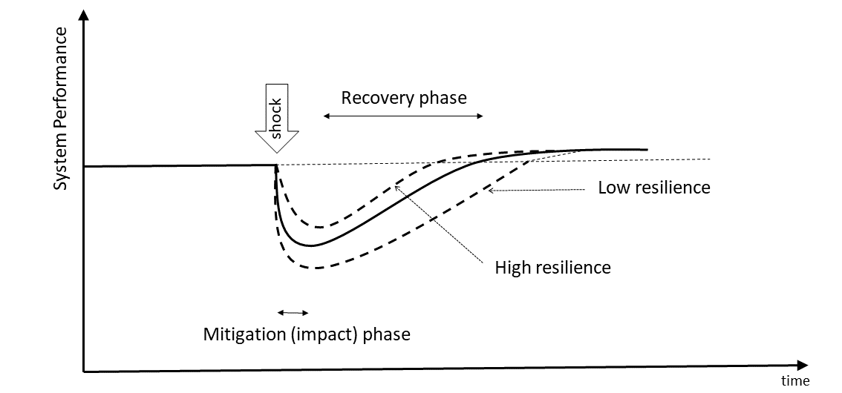
Source: JRC, 2021.

This is a new section with a horizontal page layout. This should mainly be used for the insertion of large, complex tables or graphics.
Insert two Section breaks (Next Page), then change the page orientation for this section only.
Table 2. Large table in horizontal layout
Column 1 | Column 2
Source: JRC, 2021.

- Conclusions
For the references, you should use Vancouver style, i.e. numbering in square brackets [1]. Please follow the standard referencing and make sure that all references listed are cited and that all cited references are listed in the reference list. If available, please provide doi number [1]. Examples of references according to the Vancouver style are provided in the references section.

Acknowledgements
Please insert acknowledgements, if any, before the references. Kaisa Simola and Vytis Kopustinskas of European Commission, Joint Research Centre, have adapted these Instructions from the JRC publication template.

References
- Cojazzi, G., et al. (2001) Benchmark Exercise on Expert Judgment Techniques in PSA level 2. Nuclear Engineering & Design, vol. 209, pp. 211-221, https://doi.org/10.1016/S0029-5493(01)00404-6.
- Dieulle, L., Bérenguer, C., Grall, A. and Roussignol, M. (2003) Asymptotic Failure Rate of a Continuously Monitored System, In: Sola, A., and Cojazzi, G.G.M. (eds.) Maintenance Management & Optimisation, Proceedings of the 22nd ESReDA Seminar, Madrid, Spain, May 27-28 2002. EUR 20760 EN, pp. 223-230.
- Procaccia, H., Arsenis, S.P. and Aufort P., Preface by Volta, G. (1998) European industry reliability data bank EIReDA 1998. Crete University Press.
- Toft-Christensen, P. (ed.) (1998) Industrial Application of Structural Reliability. ESReDA Safety Series No. 2, DNV, Høvik.
- Lannoy, A. and Procaccia, H. (1994) Méthode avancées de traitement et d'analyse de banques de données du retour d'expérience. Collection de la Direction des Etudes et Recherches d'Electricité de France, Editions Eyrolles N° 86, Paris.
- Singpurwalla, N. (1997) Gamma processes and their generalizations: an overview. In: Cooke, R., et al. (eds.) Engineering probabilistic design and maintenance for flood protection, Kluwer Academic Publishers, pp. 67-73.
- Asmussen, S. (1987) Applied probability and queues. Wiley series in probability and mathematical statistics, John Wiley & Sons.

List of abbreviations and definitions (only if needed)
ABΓ Alpha Beta Gamma
ΔΕΖ Delta Epsilon Zeta Delta Epsilon Zeta Delta Epsilon Zeta Delta Epsilon Zeta Delta Epsilon Zeta Delta Epsilon Zeta
JRC Joint Research Centre

() Footnote text (please always insert <tab> at the beginning). When the text is longer than one line, it is indented for a more reader-friendly layout.

